Design Document

**EXT370MI**

# Requirement

As we don’t have a standard API to modify PPS370 Purchase batch orders, we build the below API transactions.

As the customer is dependent on the supplier, before pushing order from PPS370 to PPS200, the customer would like to wait for the supplier to send the shipping charges and other information. Once we receive those details, we will modify the batch order.

In some cases, the order will be in status 20(Order entry finished), as we don't have any standard APIs to revert the order status to 10, we developed EXT370MI.UpdateStatus API to update the Order.

And API EXT370MI.UpdateLine and EXT370MI.UpdateType is built to update the order header and order line details.

These transactions also validate the data before updating the batch orders like Item number, Order type,

# Document Control

Title: Ruiz cloud

Developed by: Girish Kumar Hosamani

Date: 10/02/2023

Version: 1.0

# Design Details

## EXT370MI Transaction Overview:

Transaction Overview

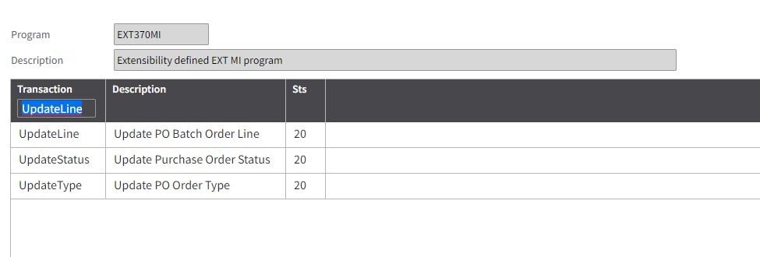

EXT370MI.UpdateStatus - To update order status from 20 to 10, because the PPS370 order needs to modify the order before pushing to PPS200.

EXT370MI.UpdateLine - To update the PPS370 batch order line before pushing it to PPS200.

EXT370MI.UpdateType -To update the PPS370 batch order type.

## Tables Overview

M3 Tables: "MXHEAD" - Purchase order batch

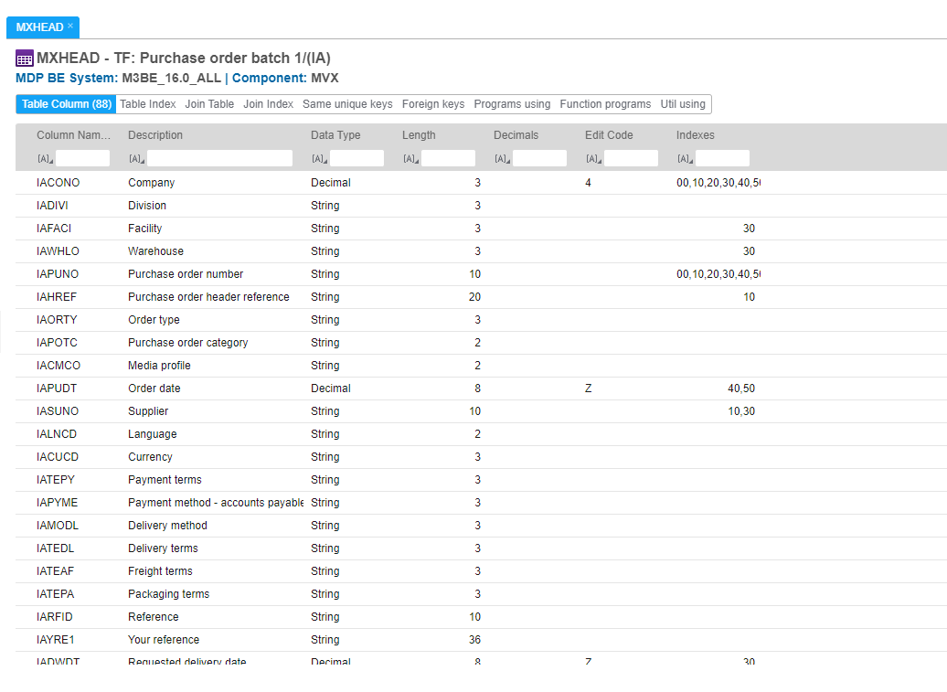

M3 Tables: "MXLINE" - Purchase order batch – line

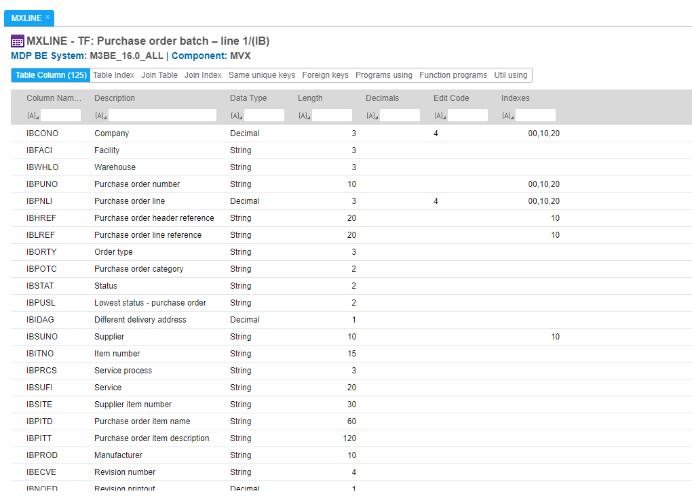

M3 Tables: "MXBETR" - PO- batch entry transactions

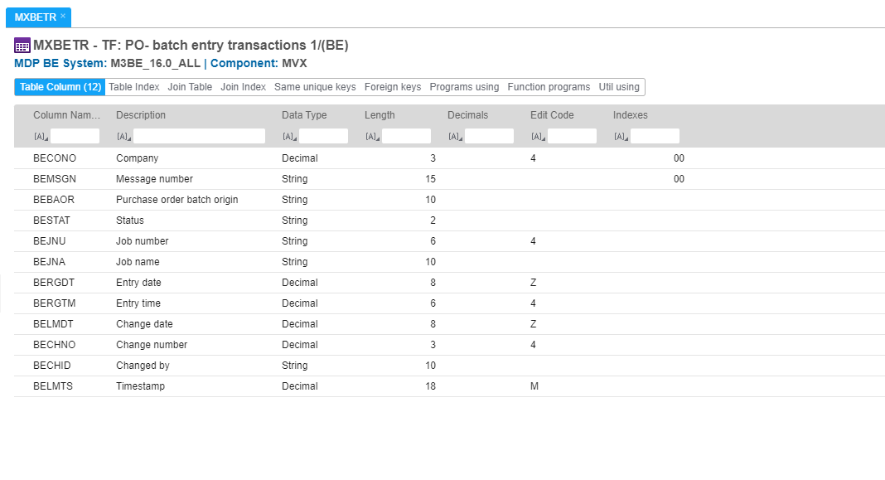

UpdateStatus

**Purpose** – To update order status from 20 to 10, because the PPS370 order needs to modify the order before pushing it to PPS200. We are updating M3 standard table MXHEAD, MXLINE, and MXBETR.

**Input Fields**

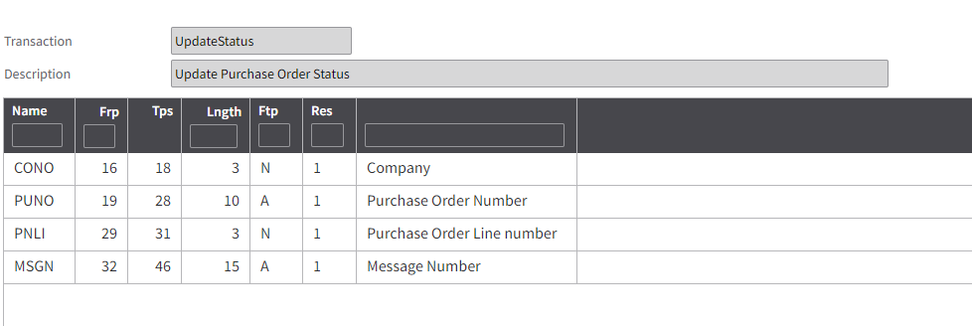

**Output Fields**

* None

**Tables Read**

“MXHEAD” Purchase order batch

“MXLINE” Purchase order batch–line

“MXBETR” PO- batch entry transactions

**Logic**

Check all the input fields are not blank.

Validating the existence of the input values, like Order line number, PO number, and Message number.

If all input values are valid then it will update the order status from 20 to 10. This will allow us to modify the PO batch order. Like price, extra charges from suppliers, order types, etc.

If an order does not exist then throw an expectation for missing records.

UpdateLine

**Purpose** – To update the Po batch line, like item, quantity, price, ship-to location, and Supplier reference number. It modifies the M3 standard table MXLINE.

**Input Fields**

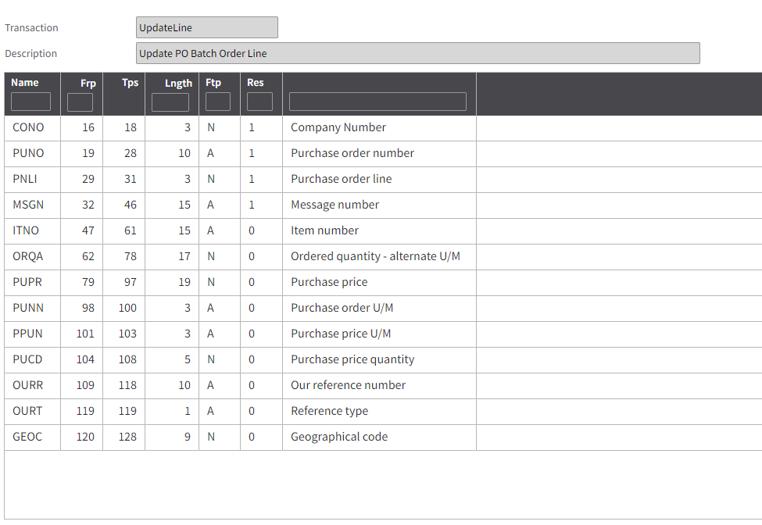

**Output Fields**

* None

**Tables Read**

“MXLINE” Purchase order batch–line

**Logic**

Check the mandatory input fields are not blank and whether input values are valid or not, like item number, order line number, and message number.

Check if the record exists in the table MXLINE for the input values if exists then update the record if it does not exist then throw an expectation for missing records.

UpdateType

**Purpose** – To update the order type.

**Input Fields**

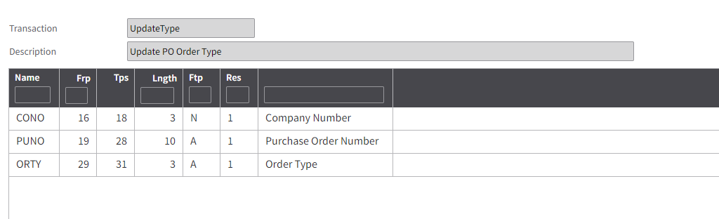

**Output Fields**

* None

**Tables Read**

“FXHEAD” Purchase order batch

**Logic**

Check all the input fields are not blank.

Validate the order types, order exists in the table FXHEAD for the input values, if it exists then update the order type if it does not exist then throw an expectation for missing records.